Press Release – for immediate release

Two YA Genre Authors to Speak to Lodi High School Students about Writing and Book Publishing - Hosted by the Lodi High School Library, LHS Creative Writing Club “Off the Page,” and Manzanita Writers Press.

~ with a Free Public Book Signing/Author Chat to Follow at Lakewood Mall in Lodi

Presenters: Young Adult Genre Authors
Durlynn Anema and R.M. ArceJaeger

Date of Event:

Tuesday, Feb. 28, 2012 from 7:20 AM to 2 PM – with a book signing and author chat at Lakewood Mall, from 3-5 PM. Free to the public.

Location of Presentation: Lodi High School – closed to the public, 7:20 AM - 2:10 PM

Public signing and author chat: Lakewood Mall in Lodi– free to the public 3:00-5:00 PM

Contact: Monika Rose mrosemanza@jps.net or mrose@lodiusd.net for more information.

About the Presenters:

Durlynn Anema – Author of the new book about teens and divorce, Hey, Mom and Dad, Remember Me?

“Is the divorce my fault?” asks one teen. A tween asks, “What is going to happen to me?” And what does non fiction writing have to do with these questions?

Lodi High School students and parents will gain the answers to those questions and more on February 28 when author Durlynn Anema visits Lodi High School classrooms, then shares with the public her new book at the Lakewood Mall at 3 PM.
Anema’s newest book, titled Hey, Mom and Dad, Remember Me? is written for tweens and teens experiencing a parental divorce. Statistics indicate that up to a third of tweens and teens will have a dysfunctional adult life as a result of the divorce. Anema’s publishers Anita Whelchel, National Writers Press (a royalty press) asked her to write the book because many of Whelchel’s friends still had trouble dealing with their parents’ divorce years later. As a family counselor, Anema has had many teen and adult clients troubled by their parents’ divorce. Also, she had the same experience at age fourteen. Parents and all interested adults can meet Anema at the Lakewood Mall at 3 p.m. on February 28 when she shares details about her book at the book signing.

During the day, Anema will present “What’s Up with Your Life?: Ins and Outs of Non Fiction Writing” to classes at Lodi High School. She has been a non-fiction writer of books,
newspaper and magazine articles for over thirty years. Students will be challenged to think about their own non-fiction writing experiences as well as learning additional non-fiction techniques, which can apply to all research papers.

Anema started her writing career with two employment textbooks “Don’t Get Fired” and “Get Hired” -- which still bring in royalties. She continued to write over ten textbooks for high school and college, then turned to biographical writing for young adults. Her three biographies were about women explorers and adventurers. She is especially excited about her latest book, “Hey, Mom and Dad, Remember Me?” When asked about the title, she said she always gets her “bright ideas in the middle of the night -- and rushes to write them down before I forget!”

During her long career, Anema taught journalism to high school and college students, was a school administrator, and assistant professor of communication at the University of the Pacific. She started the Senior Citizen column for The Record in 1984 -- “and now I’m enjoying the benefits I wrote about,” she added.

Anema can be contacted at www.facebook.com/durlynn and www.twitter.com/durlynn.
See her author interview with California Readers at http://www.californiareaders.org/interviews/anema_durlynn.php

A resident of Valley Springs, she enjoys travel, hiking, swimming, and being with her grandchildren -- and continues to write about everything that interests her. Contact the author: Durlynn Anema, (209) 772-2521 or (209) 329-3213 or email: durlynnag@comcast.net

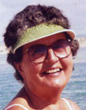

Second featured Young Adult author R.M. ArceJaeger speaks to Lodi High School classes from 7:20 am-2pm, the same day, sharing speaking time with Durlynn, and later chats with the public and signs books at the Lakewood Mall from 3:00-4:30 pm.

ArceJaeger’s presentation focuses on ebook publishing and fiction writing in the Young Adult genre. Everyone likes to tell stories. She will share with students how to turn their writing into salable ebooks that will provide royalties for the rest of their lives, at no cost to them!

Author R.M. ArceJaeger guides listeners through her excursion into ebook publishing on Feb. 28 at Lodi High School, and later the same day, she will chat with people interested in ebooks and publishing at the Lakewood Mall in Lodi. High school audience members will learn how to get started as an ebook publisher, and will be given resources to allow them to publish any written material for free. The public is invited to speak with her that afternoon at 3 PM at Lakewood Mall. Her new ebook, Robin: Lady of Legend, is available for download from many electronic sources, and has just been released January 2012.

ArceJaeger's short story, A Stepmother's Story: The TRUE Tale of Cinderella, continues to maintain stable sales on Amazon and Barnes & Noble nearly a year after its debut. Her novel Robin: Lady of Legend, is a remarkable reinvention of the legend of Robin Hood, and has just been released to all major ebook platforms as of January 1, 2012.

For more information, go to: rmarcejaeger.com and ladyoflegend.com.

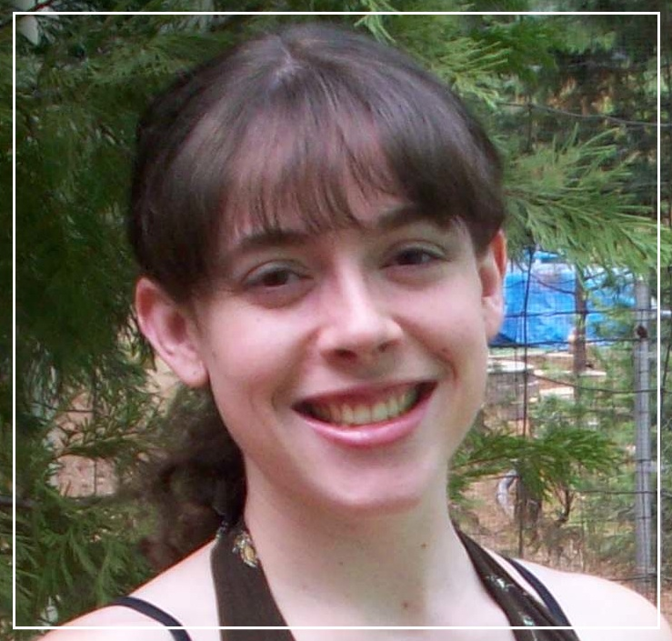

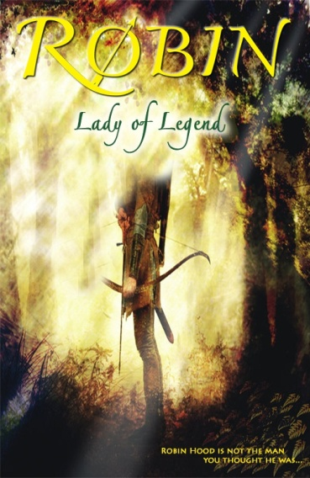

About the author:

R.M. ArceJaeger may be young, but her writing skills are professional. Named a California Arts Scholar in Creative Writing while still in high school, back in 2005, she now takes traditional fairytales and stories and twists them in compelling and revolutionary ways. She graduated from Bret Harte High in Angels Camp in the foothills in 2006 and went on to obtain a Bachelor of Science Degree in Computer Science from Harvey Mudd College. When asked why she chose to pursue a degree in science rather than in writing, she said, “I didn’t want to limit myself. I knew that if I got a degree in writing, then all I could really do was write, but if I got a degree in a STEM field, then my options would be much broader.”
ArceJaeger has utilized her art and science background, freelancing as a website designer, manuscript editor, and ebook formatter, in addition to running her own publishing company, Platypus Press and also being on the staff of Manzanita Writers Press. Her Platypus Press produces traditional (printed) and electronic publications, but specializes in publishing books onto Kindle, Nook, and iPad. ArceJaeger credits her computer science education with the success of her Press. “I can handle anything my clients want, because I understand the technology I’m dealing with. That is a huge advantage over a lot of other publishers.”
In spite of the demands of her press, ArceJaeger has still found the time to cultivate her own writing ability, which she demonstrates in her newest book, Robin: Lady of Legend, due out January 1, 2012. A reinvention of the classic tale of Robin Hood, ArceJaeger’s book offers readers a unique twist: Robin Hood is a female. The book provides girls with an empowering heroine of their very own while still thrilling audiences of both genders.

Contact: R.M. ArceJaeger email: rmarcejaeger@gmail.com

Hosts of the event:

Lodi High School Library: Linda Brandt, Librarian
Manzanita Writers Press, MWP, a nonprofit literary press in San Andreas, CA, and an affiliate of the Calaveras County Arts Council. Manzanita Writers Press assists selected authors with their publishing needs, publishes authors in our region, gives advice on self-publishing and publisher services, publishes the Manzanita series of anthologies, and hosts Writers Unlimited, an all-genre writers group that meets in San Andreas every month for feedback on manuscripts-in-progress, craft sharing, and networking. For more information, contact Monika Rose at mrosemanza@jps.net and visit the website at www.manzapress.com

For event information, contact Monika Rose mrose@lodiusd.net or mrosemanza@jps.net

