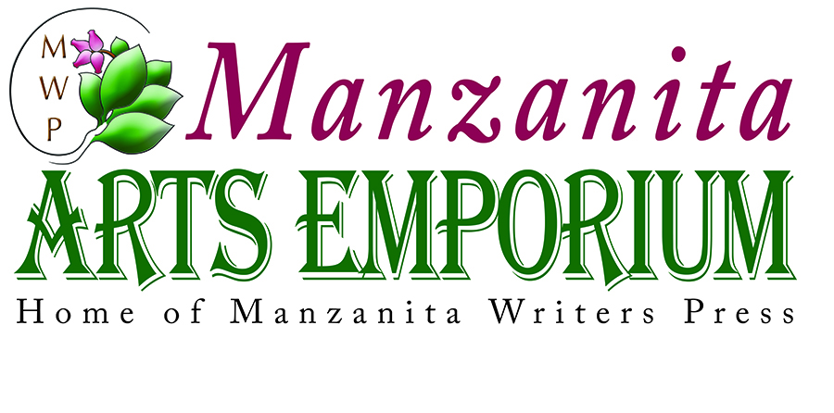
1211 S. Main St., Angels Camp, CA 95222 • 209-728-6171 • manzanitawp@gmail.com
manzapress.com• Hours: Wednesday through Monday, 11-5 - Publishing services for writers • manzapress.com
Manzanita Writers Press is a non-profit 501 (c) 3 creative arts organization devoted to the development and support of the literary and visual arts community in Calaveras County and the wider Mother Lode region. Classes – Lectures – Workshops – Artist Cooperative – Literary and Arts Center
September 2017 Calendar
September’s Featured Artist Patty Payne: Visit the Gallery this month to enjoy a fresh selection of works including bovine and equestrian subjects. Patty is at home in realistic as well as abstract art work, painting on large canvases or wood, with rustic, wood, natural frames made by husband Don Payne from field fencing, window frames, cedar, and other natural woods.
Monday, September 18: Daytime Writers Unlimited Meetings in Angels Camp at MAE from 9-11:30 am. Writing exercise and sharing, plus manuscript feedback with fellow writers. Craft sharing, resources, editing by colleagues all available. Join the group – 18 & over. $35 annual membership. Sample meeting free.
Mondays, September 11 and 25: Evening Writers Unlimited Meetings in Angels Camp at MAE from 6 to 9 pm. Share work, prose and poetry, and all genres and levels, with kind writers. Craft exchange, resources, editing by colleagues all available. Sign up to be a Member – 18 & over. $35 annual membership. Sample meeting free.

Tuesdays, September 5, 12, 19, 26 - Voices of Wisdom, Preserving the Stories of Our Elders, a free writing class series designed for 55-plus seniors, continues at the San Andreas Senior Center, 956 Mountain Ranch Road, San Andreas. Participants take all four sessions and write toward a finished essay or memoir. Participants from Session One are welcome to join in. The writing program is made possible by a generous grant from the Calaveras Community Foundation. Each class is capped at 16, so sign up by calling Manzanita Arts Emporium at 728-6171 or email at manzanitawp@gmail.com. FREE! Stay for lunch at the Senior Center if you’d like – just $6, what a deal!
Saturday, September 16, from 6 to 9 PM. Manzanita Writers Press kicks off its Second Annual ArtsHarvest Dinner Dance fundraiser at The Pickle Patch in San Andreas, music by popular band Mumbo Gumbo. Tickets $45 Purchase online– This event will sell out, so get your tickets early! Ticket prices are the same as last year. Silent auction includes Tahoe cabin getaway and other fantastic items for bidding. Local artists’work, a raffle, no-host beer and wine by the glass, and more. Reserve your spot.

CLASSES at The Emporium
Friday, September 15 from 6 to 9:30 pm: “Sip N’ Paint with Artist Mary Sexton” $45 cost covers all painting materials. Complimentary beverages and wine. Participants enjoy a relaxing group setting where painting is an activity that allows stress to disappear and worries to fade. To reserve a space, contact marysexton@comcast.net or call 209-770-5818, or sign up with a card for art classes or call 209-728-6171.

Sunday, September 27, 6 to 7:30 pm: Cristi Canepa’s Photography Class, a refresher of her July and August classes. The $25 fee covers all class materials. Participants bring their own camera. Due to this subject’s popularity, spaces in the class will fill quickly. Reserve a space by calling 209-728-6171 or clicking on art classes at manzapress.com. Use a credit card to reserve Check www.manzapress.com for the schedule.
Ongoing Weekly Piano lessons with Chrys Mollett at Manzanita Arts Emporium. Sign up with Chrys at 209-728-1439 or for more information. Dates and times vary. Call for an appointment.
Mark Your Calendar: Friday, October 20, 9am-5pm – MWP hosts a day of workshops focused on developing a story: ” with “Ernie Sites, Cowboy Poetry,” Pat Kaunert, “Mark Twain Style of Exaggeration,” MWP, “Prepare Your Story for Publication,” Storytellers Guild, “Spin a Yarn,” Local business, Writing Effective Narrative for Facebook Marketing, and Chrys Mollett, “Find Your Voice.” Saturday, October 21, MWP hosts a Liar’s Contest at the Mark Twain Wild West Fest to celebrate the great Mark Twain tradition of exaggeration, wit, and humor. Four age categories and local merchants provide prizes for winners. More information at manzapress.com.

